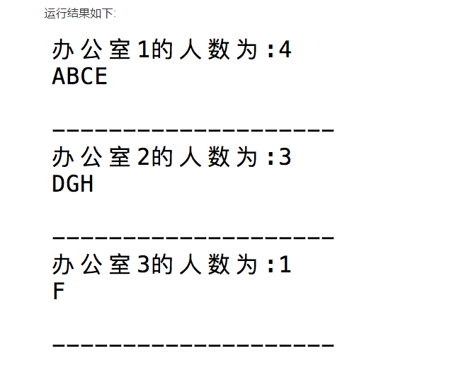

**import random *#引入random库*rooms = [[],[],[]] *#定义教室  
  
# teachers = list('ABCDEFGH') #定义老师*names = ['A','B','C','D','E','F','G','H']  
  
  
for name in names:  
 index = random.randint(0,2)  
 rooms[index].append(name)  
print(rooms)  
  
i = 1  
for teacher in rooms:  
 print('办公室%d的人数为%d' % (i,len(teacher)))  
 i += 1  
 for jiaoshi in teacher:  
 print('教师 % -5s' % jiaoshi,end='')  
 print()  
 print('-'*18)**